Click the newly created Virtual Machine below “My Computer” to start by powering on the virtual machine.

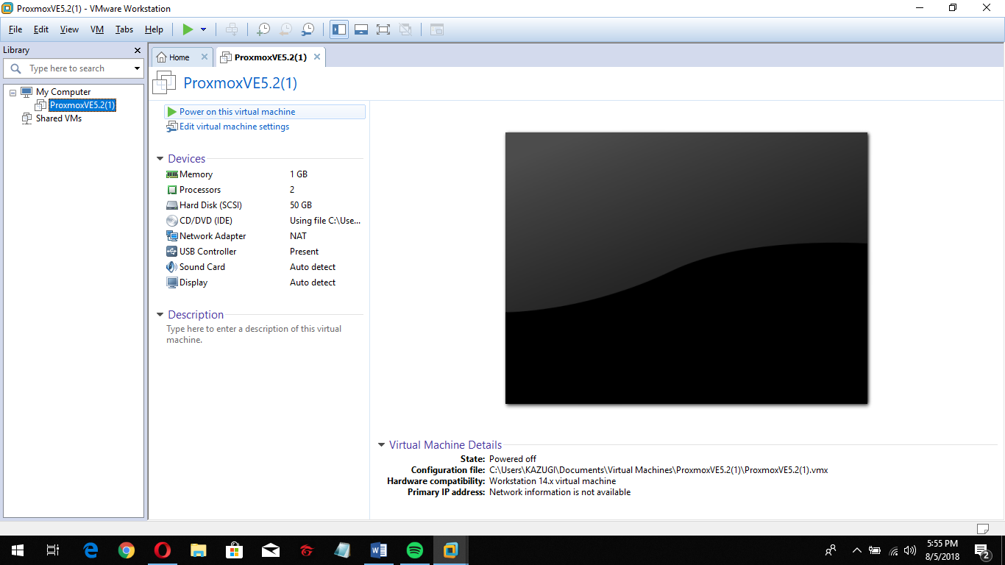

Choose “Install Proxmox VE”.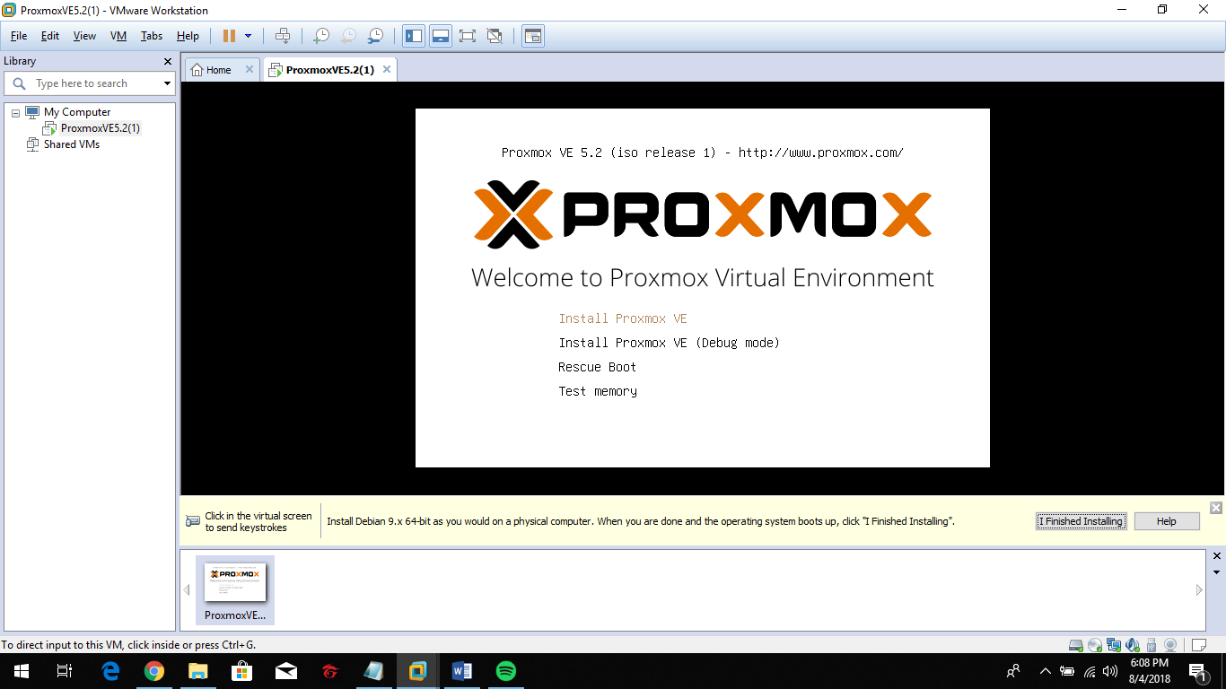

Just click “I Agree” to proceed.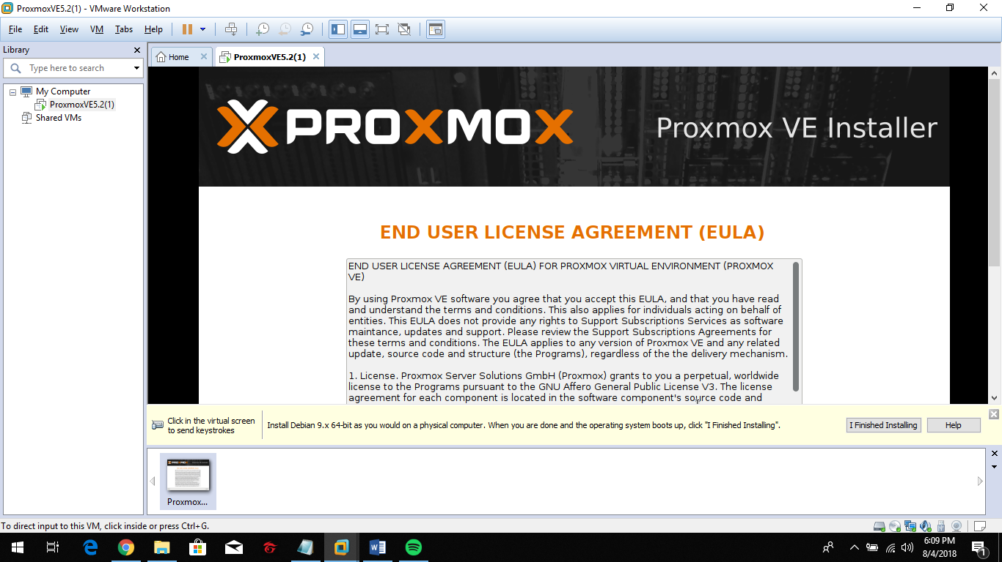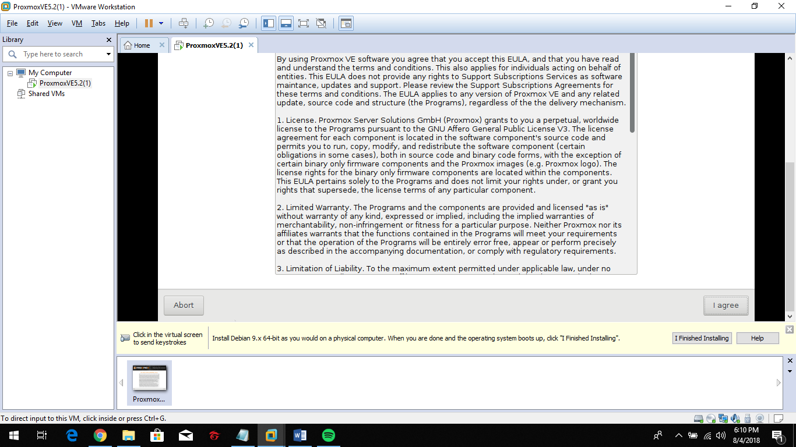

Just leave it the same and click next.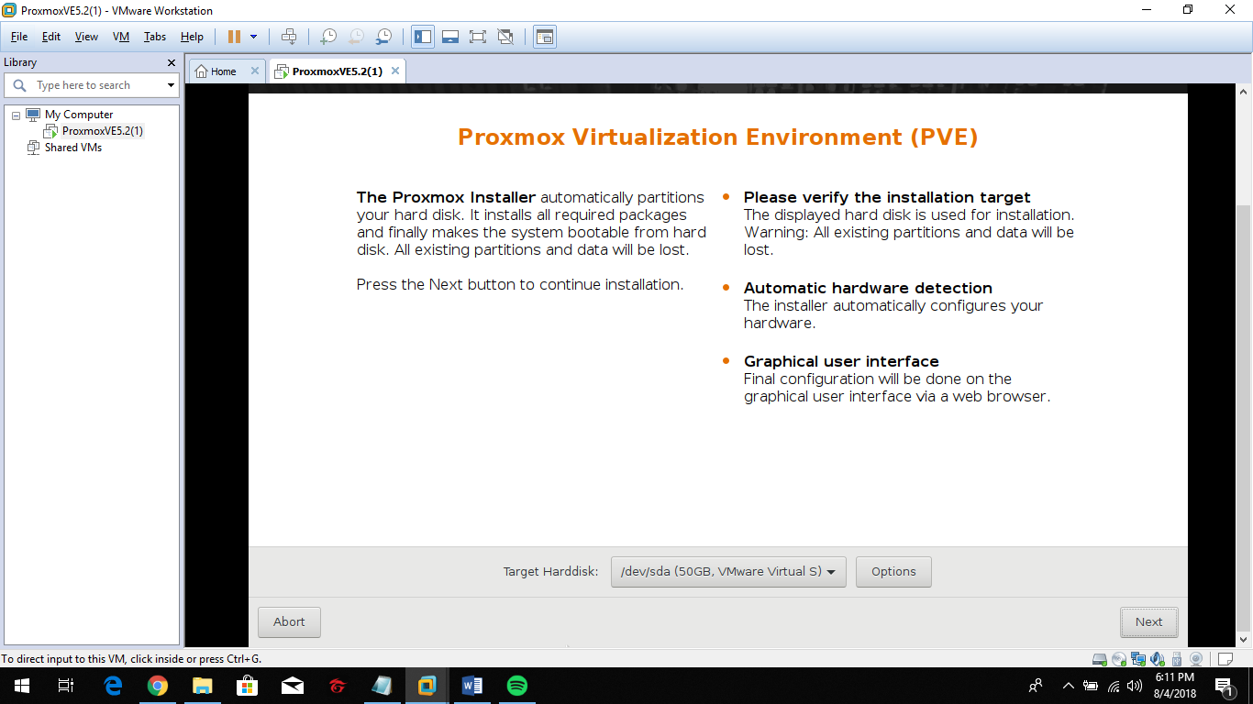

Set the “Country” to automatically configure “Time zone” and click next.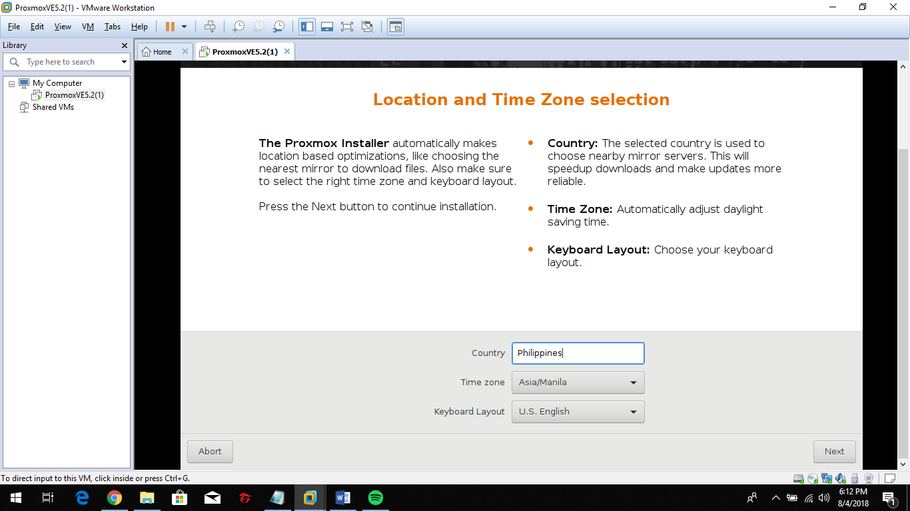

Set “Password” & enter “Valid E-mail” and click next.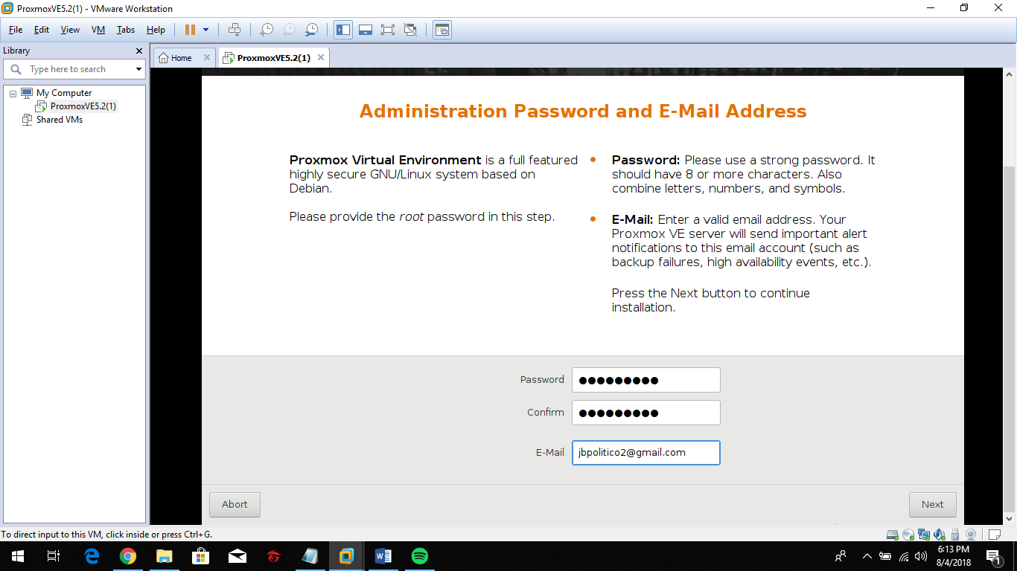

Set the “Hostname (FQON)” and click next to start the Virtualization Platform.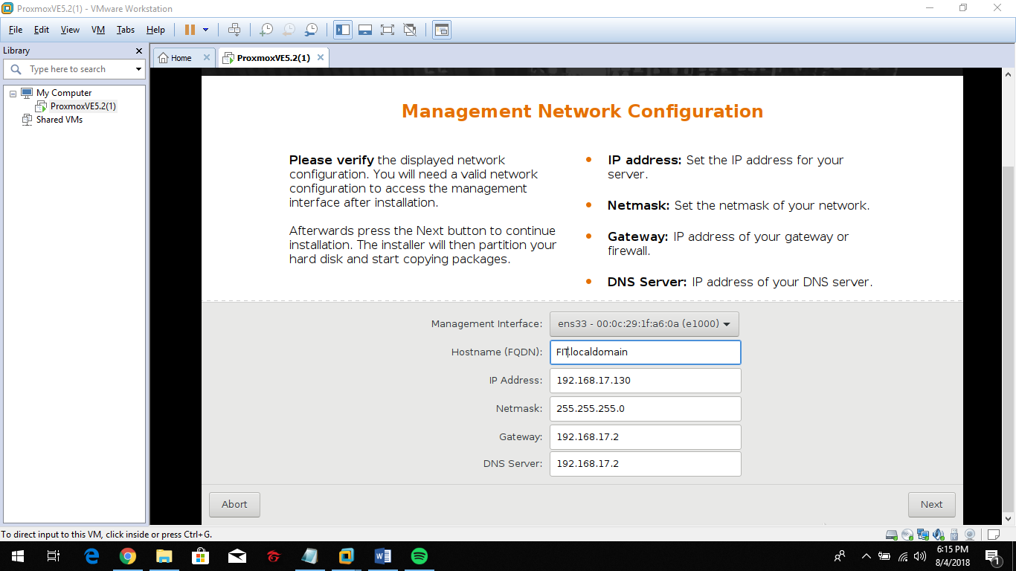

Virtualization Platform started. 